17.35: Using Q=mgh in Eq. (17.13) and solving for 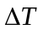 gives

